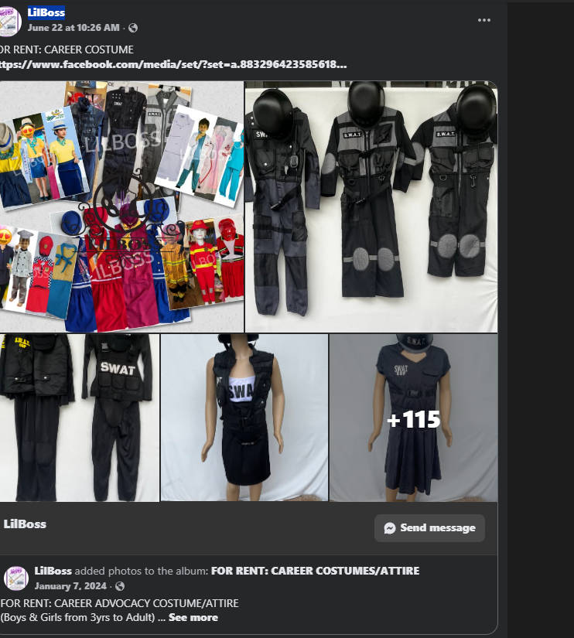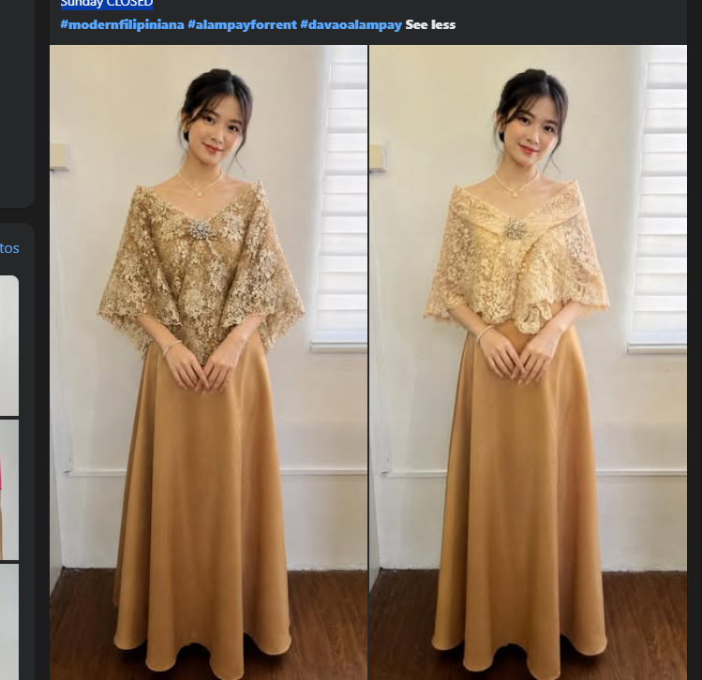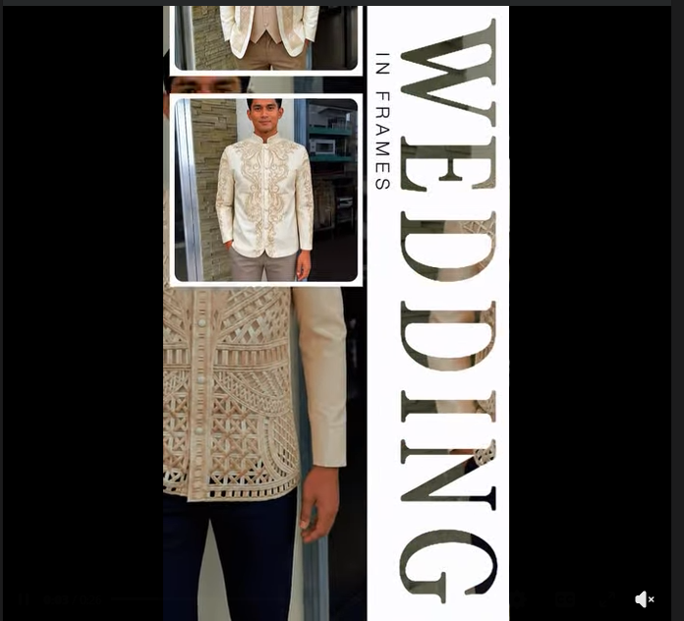NEW FOR RENT: Elegant Lace Alampay
𝑷𝒆𝒓𝒇𝒆𝒄𝒕 𝒇𝒐𝒓 𝒚𝒐𝒖𝒓 𝒕𝒊𝒎𝒆𝒍𝒆𝒔𝒔 𝑭𝒊𝒍𝒊𝒑𝒊𝒏𝒊𝒂𝒏𝒂 𝒍𝒐𝒐𝒌
